1. **Program to find maximum of three numbers using AWT.**

import java.applet.*;

import java.awt.*;

import java.awt.event.*;

public class Max extends Applet implements ActionListener {

TextField t1,t2,t3,t4;

Button b1;

public void init() {

setLayout(null);

t1 = new TextField(25);

t1.setBounds(100,25,80,20);

t2 = new TextField(25);

t2.setBounds(100,50,80,20);

t3 = new TextField(25);

t3.setBounds(100,75,80,20);

t4 = new TextField("RESULT");

t4.setBounds(100,160,80,20);

b1 = new Button("FIND");

b1.setBounds(230,65,50,30);

add(t1);

add(t2);

add(t3);

add(t4);

add(b1);

b1.addActionListener(this);

}

public void actionPerformed(ActionEvent e) {

int i,j,k;

i = Integer.parseInt(t1.getText());

j=Integer.parseInt(t2.getText());

k=Integer.parseInt(t3.getText());

if(i>j) {

if(i>k)

t4.setText(""+i);

else

t4.setText(""+k);

}

else

{

if(j>k)

t4.setText(""+j);

else

t4.setText(""+k);

}}

public static void main(String args[]){

new Max();

}

}

/* <applet code="Max.class" height=300 width=300>

</applet> */

**OUTPUT**

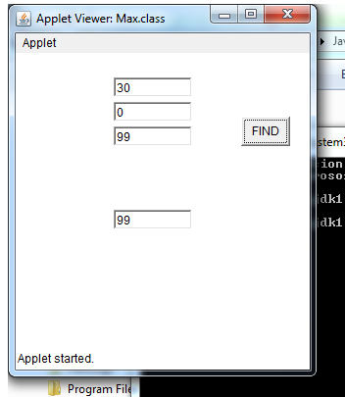

**2. Develop a program to handle all mouse events and window events**

import java.awt.*;

import java.applet.*;

import java.awt.event.*;

public class MouseDemo extends Applet implements MouseListener,MouseMotionListener {

int mx=0;

int my=0;

String msg="";

public void init(){

addMouseListener(this);

addMouseMotionListener(this);

}

public void mouseClicked(MouseEvent me) {

mx=20;

my=40;

msg="Mouse Clicked";

repaint();

}

public void mousePressed(MouseEvent me) {

mx=30;

my=60;

msg="Mouse Pressed";

repaint();

}

public void mouseReleased(MouseEvent me) {

mx=30;

my=60;

msg="Mouse Released";

repaint();

}

public void mouseEntered(MouseEvent me){

mx=40;

my=80;

msg="Mouse Entered";

repaint();

}

public void mouseExited(MouseEvent me){

mx=40;

my=80;

msg="Mouse Exited";

repaint();

}

public void mouseDragged(MouseEvent me) {

mx=me.getX();

my=me.getY();

showStatus("Currently mouse dragged"+mx+" "+my);

repaint(); }

public void mouseMoved(MouseEvent me) {

mx=me.getX();

my=me.getY();

showStatus("Currently mouse is at"+mx+" "+my);

repaint();

}

public void paint(Graphics g){

g.drawString("Handling Mouse Events",30,20);

g.drawString(msg,60,40);

}

}

/*<applet code="MouseDemo" width=300 height=300>

</applet>*/

**OUTPUT**

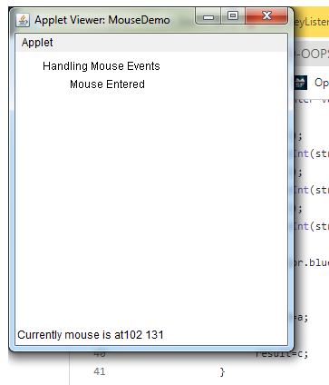

**4. Develop a program to handle Key events.**

import java.awt.*;

import java.awt.event.*;

import java.applet.*;

public class Keys extends Applet implements KeyListener{

String msg="********TYPED***********";

int x=30,y=50;

public void init(){

addKeyListener(this);

requestFocus();

}

public void keyTyped(KeyEvent ke) {

msg+=ke.getKeyChar();

repaint();

}

public void keyReleased(KeyEvent ke) {

showStatus("Key Up!");

}

public void keyPressed(KeyEvent ke) {

showStatus("Key Down!");

}

public void paint(Graphics G) {

G.drawString(msg,x,y);

}

}

/*<applet code="Keys" width=300 height=300></applet>*/

**OUTPUT**

